**Introduction to PiCar****-b**

## 1. About PiCar Pro products

PiCar-b is a kind of open source intelligent robot product that is intended for AI and robot lovers and students. It is also an open robot development platform based on Raspberry Pi with the following features:

**Easy to assemble:** modular structure design, open hardware list and detailed assembling tutorial.

**Easy to learn:** provide complete and detailed development tutorials and sample code on algorithm and application.

**Multi-configurations:** can be changed into different types of trolleys through different combinations, for example, the manipulator trolley and ultrasonic trolley.

**Multi-functions:** automatic obstacle avoidance, color recognition, moving object detection, web remote control, OLED display, lighting indicator, and line tracking with the tracking module.

**Acrylic structure:** strong and durable.

**Extensible:** extensible structure and DIY.

**Web remote control:** the robot can be controlled by mobile phones, tablets, computers, windows, Linux,and Mac OS via Google Chrome browser.

**Support Raspberry Pi in different versions:** support Raspberry Pi 3B, Raspberry Pi3B + and Raspberry Pi 4.

**Support Python**

## 2. About The Tutorials

This documentation is for software installation and operation guide for the Python robot product. It describes every detail of the whole process of fulfilling the robot project by Python and Raspberry Pi from scratch as well as some precautions. Hope you can get started with the Raspberry Pi robot on Python and make more creations with this documentation.

According to the different situations of different users, there will be some changes in the process of this document, you can refer to the following process:

* **Novice use flowchart:** Suitable for users who are new to Raspberry Pi or want to learn more about the functions of parts.

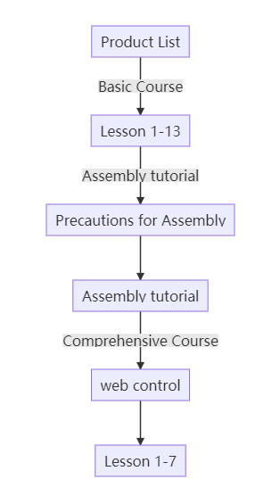

* **Flow chart for users familiar with Raspberry Pi or want to make this robot quickly:**

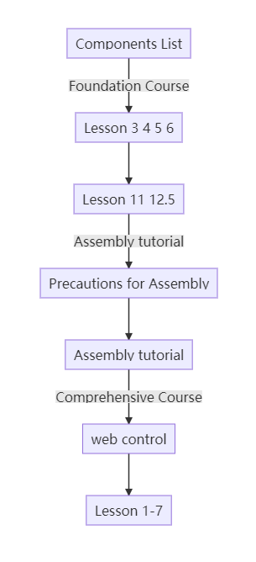

**3.** Resources Links

# 

[RobotName]: Adeept_PiCar-b

[RobotURL]: https://github.com/adeept/adeept_picar-b

[RobotGit]: https://github.com/adeept/adeept_picar-b.git

[Official Raspberry Pi website]: [https://www.raspberrypi.org/downloads/](https://www.raspberrypi.org/downloads)

[Official website]:  [https://www.adeept.com/](https://www.adeept.com)

[GitHub]:  https://github.com/adeept/adeept_picar-b/

[Image file and Documentation for structure assembly]:

[https://www.adeept.com/learn/detail-33.html](https://www.adeept.com/learn/detail-50.html)